**Arianne Mae S. Mosende**

**BSCS-1B1**

**Documentation: Contact list app**

* **Description of the study**

In the contact list app, you've implemented a user-friendly interface using Tkinter in Python to manage a list of contacts. This application provides essential functionality for adding, deleting, viewing, and editing contacts. Users can effortlessly input new contact details, delete existing contacts, and view individual contact information through a simple click interface. The contact list app serves as a practical tool for organizing and maintaining contact information efficiently.

* **Benefits of the User**
* **Organization**: Users can easily organize their contacts in one centralized location, making it simple to access and manage contact information.
* **Efficiency**: With the ability to quickly add, delete, view, and edit contacts, users can efficiently update their contact list as needed.
* **Convenience**: The user-friendly interface and intuitive design make it convenient for users to navigate and interact with their contact list, saving time and effort.
* **Accuracy**: By providing a clear overview of contact details and enabling easy editing, the app helps ensure the accuracy of contact information.
* **Customization**: The app allows users to personalize their contact list by adding, organizing, and managing contacts according to their preferences.

**3. Objective**

The objective of the contact list app is to provide users with a convenient and efficient tool for organizing, managing, and accessing their contact information. The app aims to streamline the process of adding, deleting, viewing, and editing contacts, ultimately enhancing user productivity and communication. By offering a user-friendly interface and essential features such as CRUD operations (Create, Read, Update, Delete), the app seeks to simplify the task of maintaining an up-to-date contact list.

**4. Purpose of the Code**

The code serves the purpose of creating a user-friendly contact list application using Tkinter in Python. Its primary objective is to offer users a convenient and efficient way to organize and manage their contact information. Through a graphical user interface, users can effortlessly add, delete, view, and edit contacts, providing them with a seamless experience for managing their personal or professional contacts.

**5. Significance of the Code/ Study features of the Code**

* + - **User-Friendly Interface**: The code offers a clear and intuitive graphical user interface (GUI) through Tkinter, ensuring ease of use for users of varying technical expertise.
    - **Essential** **Functionality**: By incorporating core features such as adding, deleting, viewing, and editing contacts, the code addresses the fundamental needs of contact management effectively.
    - I**mproved** **Productivity**: With streamlined contact management capabilities, the code enhances user productivity by simplifying tasks related to organizing and accessing contact information.
    - **Customization** **Options**: Depending on user preferences and requirements, the code allows for potential customization, enabling users to tailor the application to their specific needs.

**6. Code**

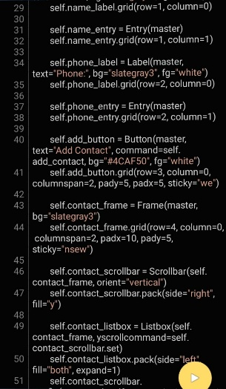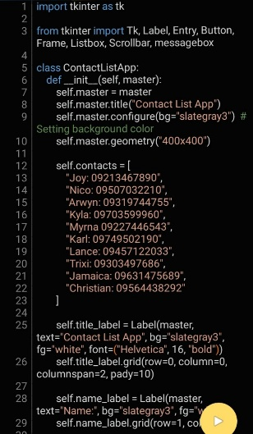

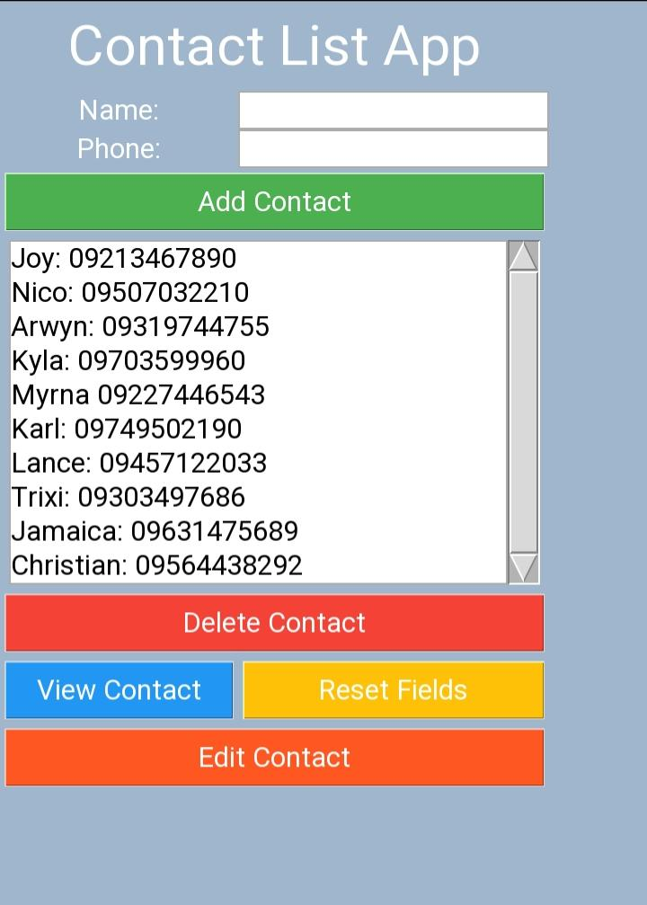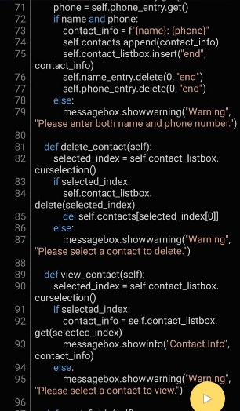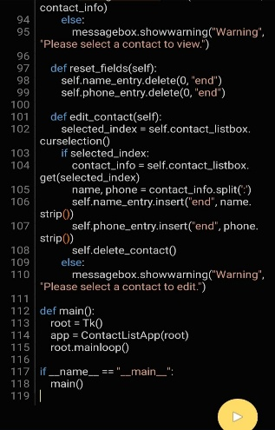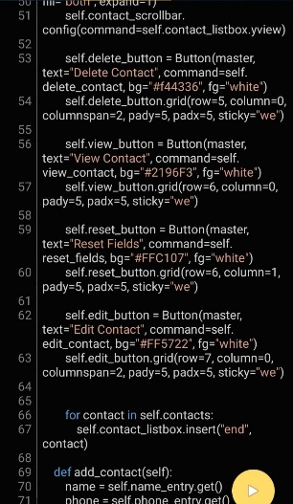

**CURRICULUMN VITAE**

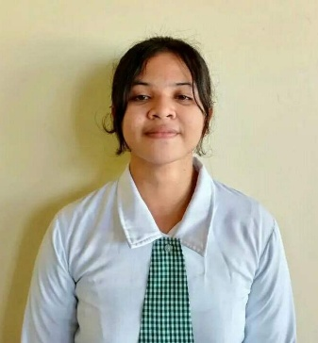

PERSONAL INFORMATION

Name: Arianne Mae S. Mosende

Contact Number: 09639130937

Email Address: yannii21mosende@gmail.com

Date of Birth: May 6, 2003

Place of Birth: Ormoc City, Leyte

Address: Purok Masipag, Brgy. Matin-ao, Mainit, Surigao del Norte

Age: 21

Nationality: Filipino

Religion: Catholic

Civil Status: Single

Mother's Name: Merlyn S. Mosende

Father’s Name: Alfonso O. Mosende

EDUCATIONAL BACKGROUND

Elementary: Matin-ao Central Elementary School (MCES)

Junior High School: Matin-ao National High School

Senior High School: Matin-ao National High School

College University: Surigao del Norte State University(SNSU)